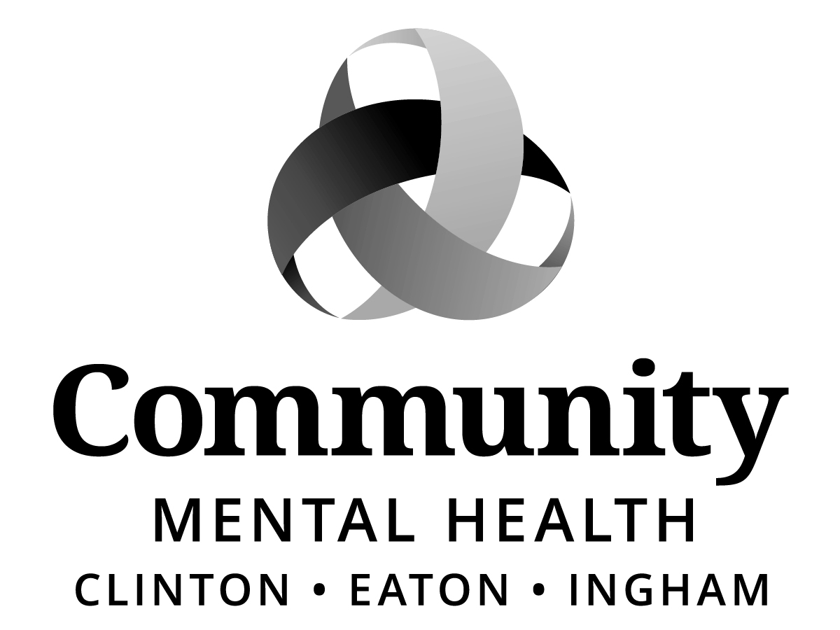
Board of Directors:
Kay Pray, Chairperson Dianne Holman, Vice Chair
Jim Rundborg, Secretary
Joe Brehler
Raul Gonzales
Carol Koenig
Stephen Manchester
Paul Palmer
Kay Randolph-Back
Chris Swope
Maxine Thome
Kam Washburn

BOARD OF DIRECTORS
AGENDA
Thursday, November 16, 2017
6:00 p.m.
Community Mental Health Authority - CEI
812 E. Jolly Road, G11-C
Lansing, MI 48910

I. CALL TO ORDER
II. ROLL CALL
III. PREVIOUS MEETING MINUTES – October 19, 2017
IV. ADOPTION OF AGENDA
V. PUBLIC COMMENT ON AGENDA ITEMS
VI. MID-STATE HEALTH NETWORK UPDATE
VII. CEO REPORT
- Quality Customer Service and Recipient Rights Administration, Joyce Tunnard, Director

VIII. COMMITTEE REPORTS
Program & Planning Committee
*1. New Expense Contract: – Jacque D. Moss, Ph.D., Okemos
*2. New Expense Contract: Mobile Medical Response, Inc. (MMR)
*3. New Revenue Contract: Medstar Ambulance
*4. New Revenue Contract: Gratiot County CMH
*5. New Revenue Contract: CMH for Central Michigan

Finance Committee
*1. Bundled: Direct Care Worker Increase

Recipient Rights Committee
Human Resources Committee
Access Ad Hoc Committee
Executive Committee
Bylaws Ad Hoc Committee
Building and Sites Ad Hoc Committee

IX. OLD BUSINESS

X. NEW BUSINESS
XI. PUBLIC COMMENT (3 minutes per speaker)

XII. ADJOURNMENT

*Action Items
If you need accommodations in order to fully participate in this meeting, please call 517-346-8238. If, however, you are deaf/hard of hearing or deaf/blind, please call Michigan Relay Center, TTY/Voice by dialing 711 or 844-578-6563 and ask them to forward your message to the above number. Requests must be made no later than 48 hours prior to the meeting. This meeting is open to all members of the public under Michigan’s Open Meetings Act.

